**IDEA**

In this idea I am trying to connect a MT (mobile terminating) call even when the user in the emergency calls only mode.

At present time when someone make a call to a person which is out of coverage area of its Home network. This type call is ended with a computer recorded voice i.e. the dialed number is not in a coverage area. But after this it will be connected to the dialed user.

The architecture of this new system is:

In this there are two separate procedure one is being performed by the user which is in emergency network. The procedure architecture is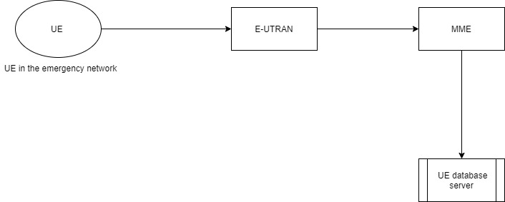

In this fistly the UE sends a attach request or PDN connectivity request to the E-UTRAN consist of the content i.e. IMSI, IMEI and MSISDN number. Complete frame formatting for this request is present in ETSI TS 131 111 V11.6.0. This frame formatting is totally based for LTE or PS network.

As when this message reaches the E-UTRAN it will forward this request to MME after allocation of a RACH channel.

Now the MME decodes this message in this message we also add some bits. Through these bits MME comes to know that this is not a call this is a request for a UE database server. After this the MME send a DER message to the UE server database after attaching the cell id. UE database servere receives this message and update this message. After receiving this message the UE server forward this message to the HPLMN of the user. After this the HPLMN comes to know where the user is. Now second procedure is started when someone call to this UE. Architecture for this is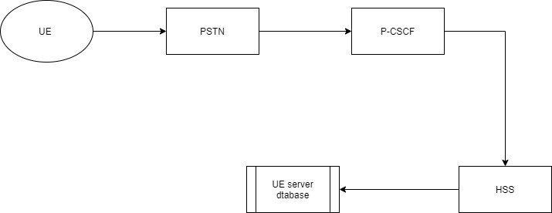 here when a person makes a call it will process the call and after processing its home network forward the call to the PSTN. PSTN connect the call the to the HPLMN of that UE which is in emergency area. The call will forwarded to to the MME for locating the user and for the paging process. But the HSS knows that the user is in the not in coverage. So it will forward call to the UE SERVER DATABASE and the data base sends the call to that cell id which is being registered in the database.

**IMPLEMENTATION AND WORKING OF IDEA.**

When any phone comes under the condition that it is in the emergency calls only mode it will send an attach request automatically for the network which is present their.

1. **Content of attach request**

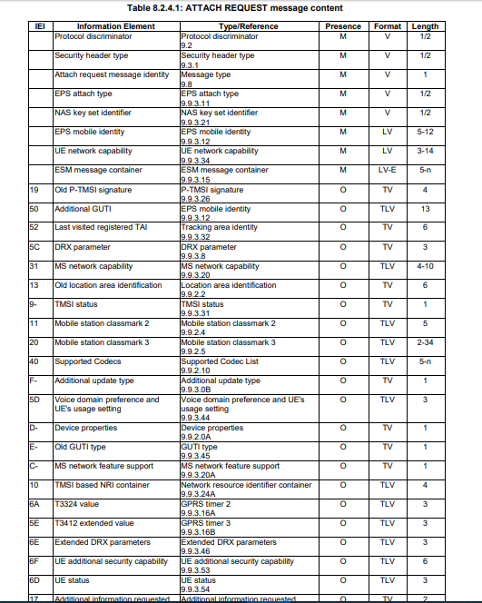

This complete information is present in the ETSI TS 124 301 V15.8.0 (2020-01) and the complete frame formatting of this content is present in the ETSI TS 131 102 V13.5.0.

In this content there is a LAI(location area identification) which contains the free bit reserved for future use.

* 1. **LAI frame format**

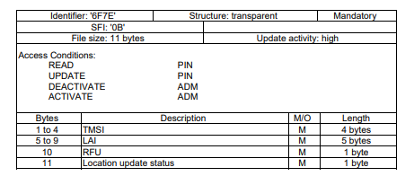

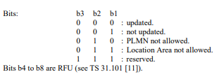

**1.2 CHANGES IN THIS ATTACH REQUEST**

So here for indicating the MME that this request is for our newly created server we use the reserved bit of LAI. After this the MME attach the enode-id and send it to the server. After this the server get to know the location area of the UE and also the nearest eNodeB ID.

1. **. SERVER Function.**

Afterreceiving the message from the MME the server creates a new ID i.e. IMSI of the UE and attach its location area and the eNodeB id with it and save it in its memory. And after that it will recognize the home network of the UE with the help of IMSI of the UE. It will then sends a ‘LAI’ info to the Home Network of the UE. After this the UE home network updates the Location information. Now whenever the UE enters into a new eNodeB coverage that network also follow the same steps as described above and the server got the message and transfer the location update message to the HPLMN. Server checks its database whether the ID is present or not if present then it will simply update the info. The procedure of our UE is done. Now next steps will be done by the home network.

Flow of this is as in the below figure.

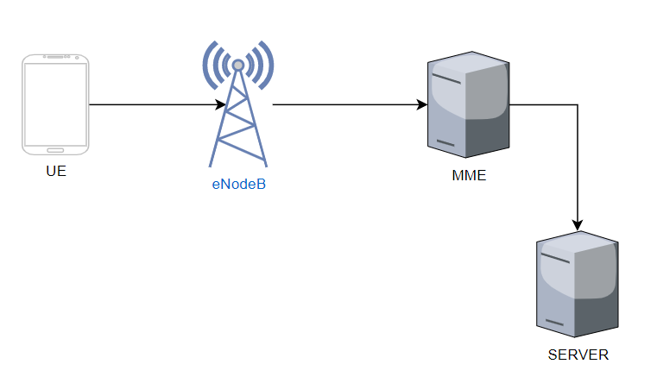

Now after this when someone make a call to this user and due to emergency calls only network connection the callee receives a computerized message i.e.” the number you are calling is not reachable” this is because when a callee call a number the callee PSTN transfers the call to the called UE PSTN. UE PSTN forwards the incoming call request to the MME and then after getting the list of TAs the MME send the request to the eNodeB and the ENB start the paging process. If the UE doesn’t responds to the paging request the ENB sends back the message to the PSTN that the called person is not available.

Our idea change the procedure after the paging response will not be send by the UE then the ENB sends a message to the SGW

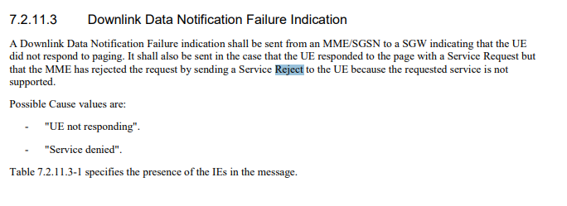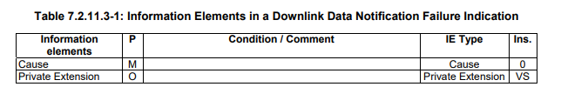Frame formatting of cause.

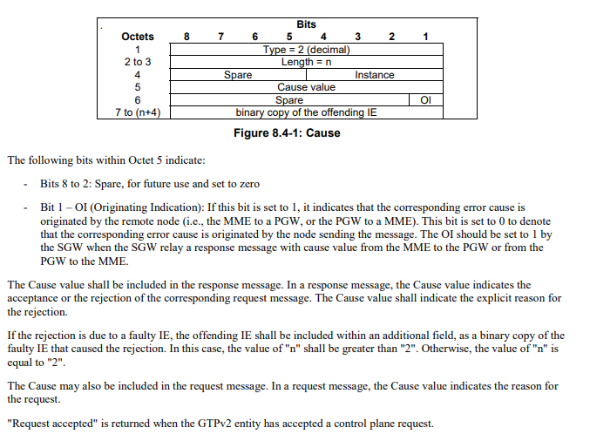

Complete info of the above frame work is present in the ETSI TS 129 274 V8.1.1.

* **Diagram based working.**

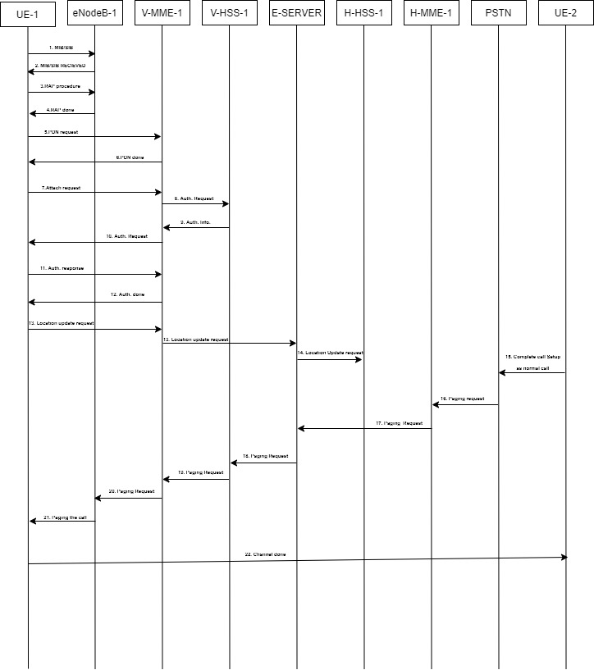

**Abbreviation Used:**

1. **UE-1- UE that is in the emergency calls only area/ called mobile.**
2. **UE-2- UE that is making a call/callee.**
3. **eNodeB-1- called mobile visited network eNodeB.**
4. **V-MME-1- Visited MME.**
5. **H-MME-1- Home MME.**
6. **V-HSS-1- Visited HSS.**
7. **H-HSS-1- Home HSS.**
8. **E-Server- Emergency Server.**

* **Procedure with explanation:**

1-14. As from step 1-14 we have discussed in section 1.3.

15. In this step the UE-2 make a call to the UE-1. The ‘PSTN’ request to connect the call.

16. In this step the PSTN routes the call from PSTN to the MME as the procedure and the message flow between these nodes is same as today.

17. In this step MME sends the location request to the HSS for proceeding the paging request. As the home network received the location info of the UE from the server so the HSS sends the location info of the UE. After receiving the location info the MME forward the request to the server. This message is called as the HO(**Handover)** request message the content of the is given in ETSI TS 136 423 V12.3.0.

18. After that the server sends the paging request message to the MME for start the paging process. For this the request message content is present in ETSI TS 129 118 V11.10.0.

19. After this the process is same as follows today.

After this complete process we can easily connect to a UE that is in the emergency calls only area.